JOB Oriented Advance IT –Course

Artificial Intelligence Associate
Cyber Security Associate
Data Analysis Associate
Cloud Computing Associate
Internet of Things Associate
Add: # 203-204, 2nd Floor< Opposite Garg Diagnostic Center
Near D.N & Sons< Circular Road ,Sirsa -125055(Hry)
Mob. 91078-15000, 91078-16000
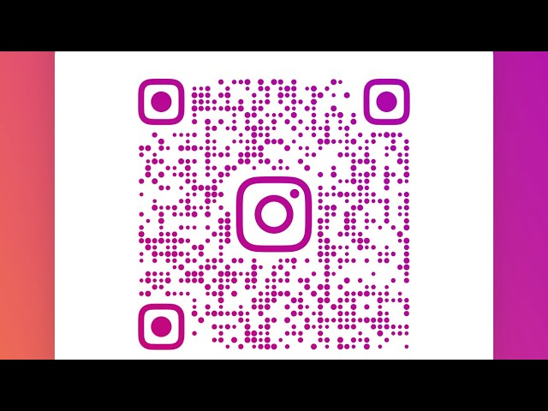

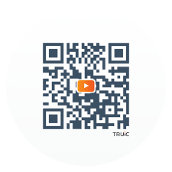
100%
Placement Assistance
Open Hours
Monday to Sunday 9:00a.m. To 6:00p.m.
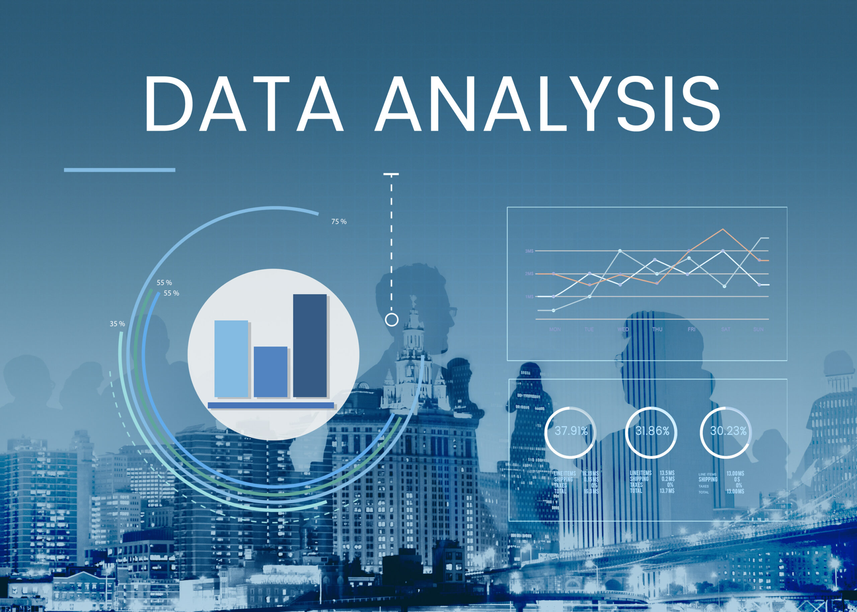




NATIONAL SKILL
QUALIFICATIION FRAMEWORK
(A STATE GOVERNMENT UNDERTAKING )
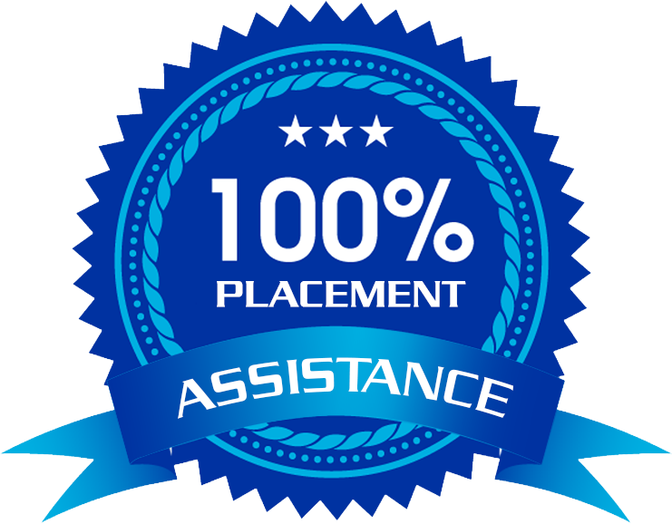
`1
HARTON
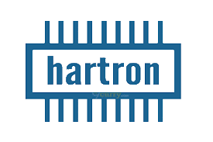 ADVANCED SKILL CENTER


3
Year
Diploma
Course
Months
Certificate
Course
6
Months
Certificate
Course

